Harris, Alan Cuthbert (based mainly on Chess Association of WA website)
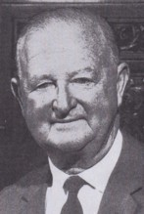
Graduated with a BSc in Forestry from the University of Adelaide. Commenced with Forests Department of W.A. 26.1.1926. Resigned 8.6.1946 to join Wood distillation and charcoal industry. Became General Manager at Wundowie 1948. Appointed Conservator of Forests 19.10.1953. Highlights of his career include widespread application of controlled burning, In 1967 the Institute of Foresters of Australia awarded him the N W jolly Medal, for outstanding contributions to forestry and forestry administration.
He spent 41 years as a Forester becoming Chief Forester for WA and was Conservator of Forests for 15 years.
Alan started playing chess as a teenager at University in South Australia before moving to WA where he was a member of the Perth Chess Club for many years. In 1958 Alan donated the original Harris Shield for the WA Inter-club competition which by 1975 had no more space for winning teams, so he presented the current trophy which is a giant rook. Best Achievements were winning the State Championship in 1935 and becoming the first life member of Chess Association of WA. Also President of Perth Football Club.

